**VHDL Practice Code**

# **HelloWorld**

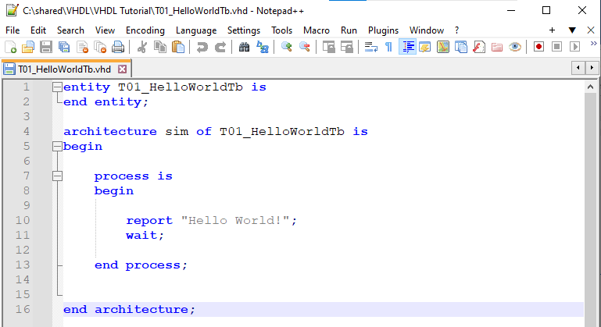

This print Hello World here no input or output

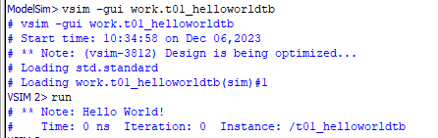

# **WaitFor**

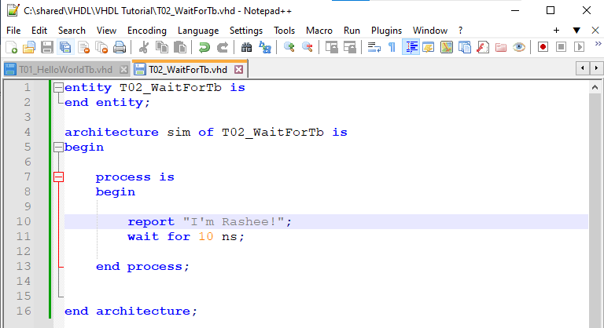

This is run in every 10 ns and we can set the simulation run time also by default is 100 ns.

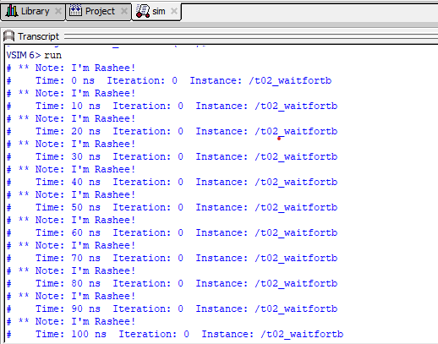

# **Loop**

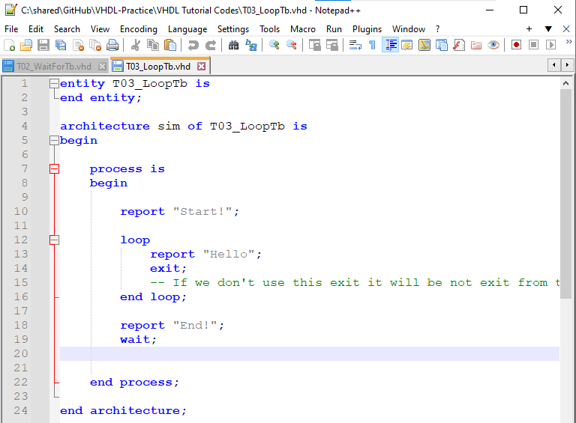

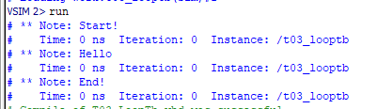

# **For loop**

# **While loop**

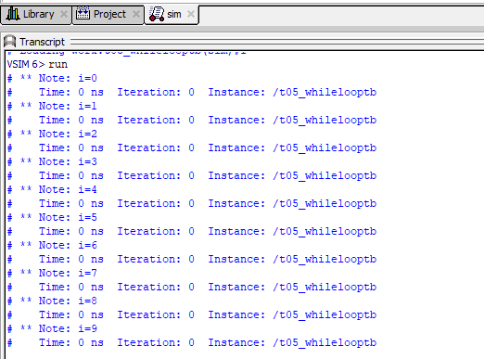

# **Signal**

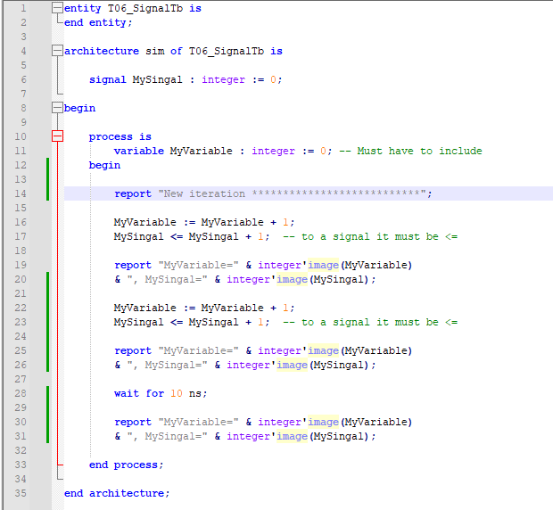

Signals are update after the wait command and variables update with every operation

# **Wait on, Until**

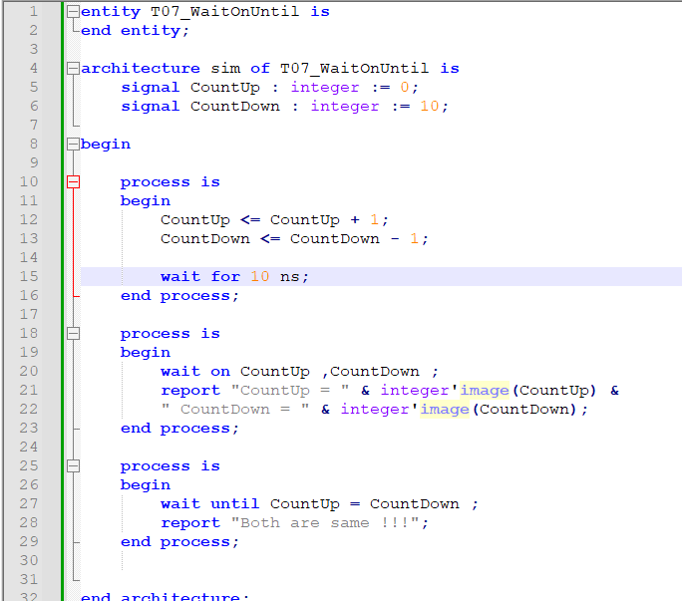

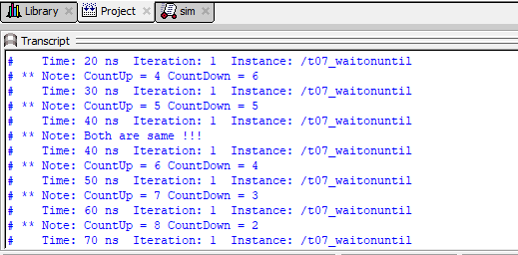

Wait on run if there is any change in signals

# **If statement**

